

**Research Ethics Screening Form**

**Do you need ethics approval?**

Looking through this checklist will help you to decide whether you are required to seek ethics approval for your research. You are advised to discuss your project, methods and ethical issues with your project/research supervisor before looking at this checklist.

**Does your intended research include any of the following methodologies?**

1. Interviews or oral histories
2. Questionnaires or surveys
3. Analysis of any kind of social media
4. Ethnography or observation
5. Any other methodology that involves animal and live human participants or their data?

If you said yes to any of the above, then you will require ethics approval for your project. Please complete the Research Approval Form on page # 2.

If you said no to all above 5 Questions then you do not require ethics approval form. Please get this form verified and signed by your research supervisor and COD and attach this in your thesis annexure.

**If you are required to submit an Ethics Review Form, you should not begin your research until your form has been approved by the Research Ethics and Support- Committee.**

**Approved By __________ Approved By_____________**

**Research Supervisor Chairman of Department**

**Date: Date:**

For Official Use Only:

Date: Reference no.



**RESEARCH ETHICS APPROVAL FORM**

**(For Scientists/Researchers/Students)**

For Official Use Only:

Date: Reference

# 

# Who Should Complete it?

This form should be completed by all participants, faculty and staff seeking ethics approval for their research to be undertaken at University of Management and Technology. All sections of the form must be completed and submitted to the ORIC at least three weeks prior to the start of their research.

|  |  |  |
| --- | --- | --- |
| **Section 1:** | **DETAILS OF RESEARCH PARTICIPANT** | |
| **UMT Participant Research Project** | | |
| **UMT Faculty/Staff Research Project** | | |
| **Other**  **If other please specify:** | | |
| **Name of The Researcher/Scientist/Participant:** | | |
| **Department/School:** | | |
| **Email:** | | **Mobile:** |
| **Supervisor’s Name:**  **Affiliation Institution/clinic and position of research supervisor:** | | **Supervisor’s Department:**  **Supervisor’s contact/ email and/or telephone**  **no:** |
| **Project Start Date:** | | **Project End Date:** |



Section 2:

DETAILS OF RESEARCH ACTIVITY

1. **Research Title:**
2. **Research Objective:**
3. **Preliminary ethical flag(s)**
   * Animal
   * Environmental
   * Data
   * Humans (Clinical)
   * Humans (non-clinical)
   * Others- Please specify

# Where will your research be conducted?

* + Research will be conducted online or social media.
  + Research will be conducted at health care, educational or other institutions. Please specify and enter here the name of institution, clinic or department etc.

# Please indicate if you have received the permission from the head (or other

# responsible) person of an institution, division, clinic/department etc.) to conduct your research?

* + Yes, the permission has been received (please attach the copy of permission)
  + No, the permission has not been received Please explain why it has not been received



Section 3:

DETAILS OF RESEARCH METHODOLOGY

# What are the type of your research and/or data collection methods:

|  |  |  |  |  |  |
| --- | --- | --- | --- | --- | --- |
| **DATA COLLECTION METHODS** | | | | | |
|  | **Experimental**  **(laboratory)** | **Observational (non-**  **interventional)** | **Epidemiologic** | **Quantitative** | **Qualitative** |
|  | * In vitro | * Clinical case report | * Cross- sectional | * Anonymous | * Semi-   structural interview |
|  | * In vivo | * Meta-analysis | * Cohort study | * Correlati onstudy | * Quantitati vedata analysis |
| **Type of research** |  |  |  |
| * Secondary analysisof biological   material | * Prospective | * Case control | * Secondar y data collection | * Focus group |
| * Secondary analysisof biological samples | * Retrospective | * Systematic dataanalysis | * Quantitati ve content analysis | * Case study |
| Other please specify the type of your research and/or data collection methods | | | | |  |

1. **What is the object of your research?**
   * Humans please specify (for example, patients, health professionals etc.). COVID-19 patients both

current and recovered

* + Anonymized health data (information), available in official databases, registries, medical history or archives (proceed to question no. 14) Please specify the criteria for information selection (for example, ICD codes etc.)
  + Human biological samples (proceed to question no. 14) Please specify the criteria for sample selection
  + Animal biological samples
  + other Please specify

# Does your research involve vulnerable individuals or groups?

* + No
  + Yes (*mark or specify vulnerable groups below*)
  + Minorities
  + Incompetent patients
  + Pregnant women
  + Competent persons with certain limitations of decision making
  + Refugees
  + Prisoners
  + Students
  + Soldiers in the active military service
  + Other

Please argue and comment why the mentioned vulnerable groups or individuals should be included in your study and how their rights will be guaranteed.

1. **What is the sample size of your research?** Please enter the number of research participants and justify it (please explain how you will determine the sample size?

**__________________________________________________________________________________________________________________________________________________________________________**



Section 4:

DETAILS OF RESEARCH INSTRUMENT

# Will you employ any kind of questionnaires for data collection in your research?

* + Yes, I will use a standardized questionnaire and the authors’ permission for its usage in my research is received.

Please attach the document that proves the permission to use the questionnaire attached with synopsis

* + Yes, I will use a standardized questionnaire with free copyright (permission is not required) Please include the evidence that the questionnaire is free to use
  + Yes, I will use an originally developed questionnaire

Please attach the copy of an originally developed questionnaire

* + No, I will not use any questionnaire
  + Other please specify and comment

# What type of a survey will you be using?

* + Face-to-face interview
  + Other, please specify



Section 5:

PROCEDURES AND POTENTIAL DISCOMFORTS

# Will you be using any kind of procedures, measurements or tests in humans (patients or clients) for data collection in your research?

* + Yes
  + No (*proceed to question no. 18*)

# Are the procedures, measurements and tests employed in your research considered as standard diagnostic and treatment procedures, measurements and tests? (*please select all that apply*)

* My research will include only those procedures, measurements and tests that are included in the treatment regimen designed by a responsible physician or other qualified specialist

Please specify and shortly describe particular procedures, measurements or tests to be used in your study:

* + My research will include additional standard procedures, measurements and tests that are not included in the treatment regimen, but administered for purposes of this study. Please specify and shortly describe procedures, measurements or tests to be used in your study and comment why they are needed:
  + My research will include non-standard procedures, measurements and tests, administered only for purposes of this study. Please specify and shortly describe procedures, measurements or tests to be used in your study and comment why they are needed:
  + Other

Please comment in detail what procedures, measurements and tests will be used and how their usage can be justified

1. **Are the procedures, measurements and tests employed in your research invasive**? ***(for example, collection of biological material etc.)***
   * **No, I will not use any invasive procedures (procee**d to question no. 18)
   * Yes, I will use invasive procedures

Please comment in detail what procedures, measurements and tests will be used and how their usage can be justified:

* + Other

Please comment in detail:

1. **Who will be performing the previously mentioned procedures, measurements and tests? (*please***

***select all that apply*)**

* + Myself

Please specify what procedures will be done by you and justify your qualification to do this:

* + Qualified health care professionals

Please comment what procedures will be done by them and justify their qualification to do this

* + Other persons

Please comment what procedures will be done by them and justify their qualification to do this

# Will you have any physical contact with your research participants during your study?

* + No
  + Yes *(if yes, please comment below how your own and research participants’ safety will be guaranteed)*

Please explain and comment here:

# What potential inconveniences might be experienced by research participants?

* + Loss of time
  + Changes in daily regimen
  + Psychological & Physical discomfort



Section 6:

Handling of Hazardous waste (Labs and Clinical)

# Does your research involve handling with hazardous chemical or clinical waste? Please refer to

# Yes, please refer to UMT Policy and SOPs for handling of Hazardous chemical and clinical waste on

# Annexure 1

* + No

# Summary of Informed Consents: (Please share Briefly About Number of Informed Consents and Attach Signed Documents Accordingly) (Please note this is a mandatory requirement). Annexure 2 for templet of consent form

1. **How the data will be stored? Please tick one of the following:**

Paper Version

Electronic Version



Section 7:

DATA PROTECTION

# Please provide details of where the data will be stored?

1. **How long the data will be retained?**

5years

10 years

# Any other approval required?

YES

NO

IF YES PLEASE SPECIFY:



Section 8: Statement of Ethical Commitment:

I pledge the commitment that all rules set by the ethical policy are followed in my research process. I also make a commitment to abide by ethical principles, moral values, law and instruction of the institutions. My research carries no bias for ethnicity, gender, regional aspects and is totally impartial and objective. I have taken informed consent from participants, participation; is on a voluntary basis and no force of any kind has been used to attract the participants.

_ Signature of Researcher/Scientist/Student

|  |  |  |
| --- | --- | --- |
| Endorsed By | Reviewed by Manager ORIC | Approved By |
| Project Supervisor & Dean |  | Chairman |
|  |  | Research Ethics & Support Committee (RESC) |
| Name of Project Supervisor: | Name: | Name: |
| Signature: | Signature: | Signature: |
| Name of School Dean:  Signature:  Stamp: | Stamp: | Stamp: |

**Annexure-1  
 **

**Guidelines for disposal of Hazardous Waste at UMT:**

**Chemical & clinical Wastes**

**Introduction:**

These guidelines have been developed for disposal of lab and sharps waste from University of Management and Technology (UMT) premises. These guidelines should be read and adhered to reduce the risks associated with the disposal of hazardous waste.

**Scope:**

These guidelines are applicable to both staff and students working in the UMT labs and University Medical Centre (UMC).

**General Principles:**

All waste produced from labs should be handled keeping in the following key principles:

1. Type of waste must be categorized as animal waste, chemical waste, clinical waste, cytotoxic waste or radioactive waste.
2. Label the container with an appropriate label by mentioning the chemical name, quantity, concentration, lab name and number, school, building name and contact phone number.
3. Store the waste container in an appropriately ventilated area before disposal. Ensure the lid of the container is tightly closed and there is no spillage on the exterior of the container.
4. The hazardous waste should only be handled by trained and nominated staff members of concerned labs.

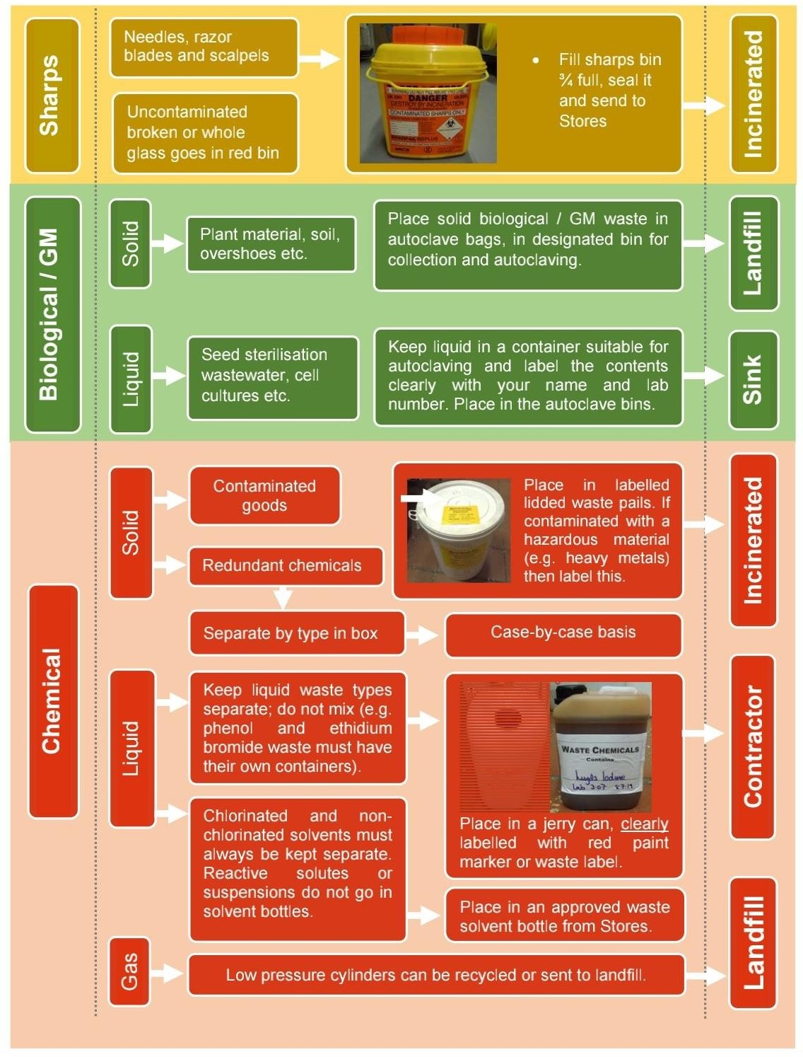

**Chemical waste:**

It includes solvents, aqueous solutions, dry powders, and unwanted old chemicals. Chemical wastes should not be mixed together to avoid unexpected chemical reactions.

1. The container (bin) must be compatible with the waste to kept into it.
2. Hazardous chemicals should *NOT* be disposed down the drain.
3. If a chemical reagent has lost its label, bottle should then be labelled as *“Caution unknown substance - Do not use”.*

**Common Laboratory Chemicals and their Hazard Class**

|  |  |
| --- | --- |
| Class | Chemicals |
| Oxidizers | Inorganic Nitrates, Nitrites, Permanganates, Chlorates, Perchlorates, Iodates, Periodates, Persulfates, Chromates, Hypochlorites, Peroxides, Perborates (ex: Potassium Perchlorate, Calcium hypochlorite, Sodium nitrate, Sodium iodate, Ammonium persulfate, Sodium peroxide) |
| Oxidizing acids | Nitric acid, Perchloric acid, Hydrogen peroxide, Periodic acid, Chromic acid |
| Flammable liquids | Methanol, Ethanol, Acetone, Xylene, Toluene, Ethyl acetate, Tetrahydrofuran, Ethyl ether, Benzene, Dimethylformamide, Acetonitrile, Hexane, Pyridine, etc. |
| Basic flammable liquids | Flammable amines such as: Triethylamine, Diethylamine, Ethylaminediamine,  Trimethylamine solution, Pyrrolidine, Morpholine,  Cyclohexylamine, Sodium methylate (in methanol solution), etc. |
| Inorganic bases | Metal hydroxides such as Sodium, Potassium, Calcium, Nickel  hydroxide Ammonium hydroxide |
| Organic bases | Amines such as Ethanolamine, Tributylamine, etc. |
| Acidic Flammable Liquids | Glacial acetic acid (100%), Acetic acid (>80%), Acetic anhydride, Formic acid (>85%), Propanoic acid (100%) (also called Propionic acid)  Mixtures of acids and flammable liquids |
| Organic Acids | Butyric acid, Pentanoic acid, etc. |
| Inorganic acids | Hydrochloric acid, Sulfuric acid, Phosphoric acid, Hydrofluoric Acid, etc |
| Poisons (Toxic chemicals) | Many are in aqueous solution, but they are also available as mixtures or pure compounds, such as Acrylamide, |

|  |  |
| --- | --- |
|  | Formaldehyde, Glutaraldehyde, Chloroform, Phenol, Methylene  chloride  Toxic metal salts such as Silver chloride, Cadmium sulfate, Mercury acetate, Barium carbonate, Lead acetate, etc.  Biological stains |
| Cyanides | Sodium cyanide, Potassium cyanide, Calcium cyanide |
| Sulfides | Lead sulfide, Iron sulfide [some metal sulfides, when they have low water content, such as Sodium and Potassium sulfides, are pyrophoric] |
| Pyrophorics (air- reactive) | Metal alkyls and aryls, such as Methyllithium,  Trimethylaluminum, Diethylzinc, phenyllithium  Nonmetal alkyls, such as Triethylborane, Trimethylphosphine Phosphorus (white)  Note: Careful when packaged under water, don’t store in an area where water reactives are present  Metal alkyl hydrides and halides such as Diisobutylaluminum hydride, Dimethylaluminum chloride,  Titanium trichloride, tert-Butyl hypochlorite, Lithium  diethylamide, Lithium diisopropylamide, Sodium methoxide (Sodium methylate), Sodium sulfide [anhydrous or <30% water], Raney Nickel Catalyst |
| Water-reactives | Alkali metals such as Sodium,Lithium, Potassium  Metal powders such as Alumium, Cobalt, Iron, Magnesium, Manganese, Palladium, Platnium, Tin, Titanium, Zinc,  Zirconium  Borane complexes such as Borane-dimethylamine complex, Borane-methyl sulfide complex  Carbides such as Calcium carbide  Grignard reagents such as Phenylmagnesium bromide, Ethylmagnesium chloride  Metal hydrides and Borohydrides such as Sodium hydride, Potassium borohydride, Lithium aluminum hydride  Metal phosphides such as Aluminum phosphide, Calcium phosphide, Sodium phosphide  Others: Trichlorosilane, Phosphorous pentasulfide |
| Water-Reactive  acids | Chlorosilanes such as Dimethyldichlorosilane,  Ethyltrichlorosilane  Acid halides such as Acetyl chloride,Benzenesulfonyl bromide, Propanoyl chloride  Phosphorous pentoxide (also called Phosphoric anhydride, when mixed with water, may boil from the heat generated) |
| Non-Hazardous or  non-regulated chemicals | Buffers, Surfactants, Ion exchange resins, Alumina, Silica,  Culture media, Agarose, Albumin, Pump oil,  Non-hazardous salts such as Sodium chloride, Magnesium sulfate, Potassium phosphate, Calcium acetate, etc.  Note: Always look for the presence of toxic preservative compounds in “non-hazardous products” such as. Mercury or Azide salts in buffers] |

# Sharps Waste:

Sharps waste includes items having rigid corners, edges or points that can cut or penetrate into the skin e.g. hypodermic needles, broken glass, scalpel blades, lancets, syringes with needles, razor-blades etc. Such sharp wastes should be placed in appropriately labelled sharps container any sharps and should be kept close to the area where sharps are used.

# Cytotoxic Drugs and Related Waste:

* 1. Segregate the Cytotoxic Drugs and Related Waste from other wastes.
  2. Place all Cytotoxic wastes in tightly sealed containers/bins that are marked with the white Cytotoxic label. If the cytotoxic waste is sharp, then place waste into sharps container.
  3. The container should be placed in a dedicated area for collection by the concerned authority for final disposal.

# Animal Waste:

Please use the following guidelines to dispose animal waste:

* + - Waste (litter) from animals that has been used for research, demonstration or educative purposes associated with The University of University of Management and Technology.
    - Animal carcasses and parts thereof that are not classified as Clinical and Related waste or Cytotoxic Drugs and Related waste
    - Used animal food stuff. This excludes the following:
    - Any of the above ‘animal waste’ that is in anyway contaminated with an infectious agent;
    - Licensed activities;
    - Clinical And Related Waste;
    - Cytotoxic Drugs and Related Waste; and
    - Human Cadavers.

# 1. Procedure

The preferable method for disposal of animal waste is incineration or composting or treating at high temperature via autoclave.

Due to the unavailability if incinerator in or near by the University of Management and Technology, this method is not applicable and composting is not a favorable activity because of the proximity of the local community. For infectious or contaminated material, the wastes shall be disposed of as the waste it is contaminated with (i.e. clinical and related, chemical or radioactive. Otherwise, the following measure shall be taken for disposal of the wastes.

* + - All animal waste will be placed and sealed in a plastic bag. The plastic bag may be of any type, but shall not be coloured red, yellow or purple (as these indicate waste of a hazardous nature.
    - The bag shall be placed into a closable container marked as “Animal Waste” within a freezer. The container is not to be overfilled such that it cannot be closed and must be in sound condition with no splits or cracks. The container shall not be placed in a freezer used for storage of food products or other materials for human consumption and should be isolated from all other contents as best as possible.
    - Once the container is full, or once it has been held for more than 2 weeks the contents of the container are to be transferred to the general waste bin.
    - The container and any other equipment that may have been used to transfer the waste shall be disinfected immediately after transferring the waste.

•

# ANIMAL TISSUE/ CARCASSES DISPOSAL

Animal carcasses that are not biohazardous can be preserved in alcohol till disposal to prevent spread of infection. Carcasses that have been chemically preserved with formalin or glutaraldehyde can be placed in two securely sealed disposal/trash bags prior to placement into the building solid waste dumpster. Any free-flowing liquids should be drained from the carcass, prior to disposal.

The drained preservative solution should be disposed in the sanitary sewer system followed by copious amounts of water.

If the carcasses have not been chemically preserved place the carcasses should be autoclaved for the purpose of prevention of spread of infection and then disposed of in two disposal/trash bags, securely seal the bags and if possible, freeze the contents. Freezing assists in preventing putrefaction, aerosols, and dripping liquids.

**Annexure-2**

 For Official Use Only:

Date: Reference no.

Participant Consent Form

I, agree to participate in the research project titled “

conducted by **“** who has discussed the research project with me.

I understand the general purposes, risks, and methods of this research.

I consent to participate in the research project and the following has been explained to me:

* the research may not be of direct benefit to me
* my participation is completely voluntary
* the steps that have been taken to minimize any possible risks
* what I am expected and required to do
* I am able to request a copy of the research findings and reports
* security and confidentiality of my personal information.

In addition, I consent to:

* audio recording of any part of or all research activities (if applicable)

**Name:**

Signature:

Date: